## **COMSATS University Islamabad, Sahiwal Campus**



COMPUTER NETWORKS LAB

Assignment # 3

## **Submitted By:**

Sana Shaheen

FA22-BCS-203

**Submitted To:**

Mam Amna Tariq

Date: May 17, 2024

**Department of Computer Science**

## **What Does Static Routing Mean?**

Static routing is a type of network routing technique. Static routing is not a routing protocol; instead, it is the manual configuration and selection of a network route, usually managed by the network administrator. It is employed in scenarios where the network parameters and environment are expected to remain constant.

Static routing is only optimal in a few situations. Network degradation, latency and congestion are inevitable consequences of the non-flexible nature of static routing because there is no adjustment when the primary route is unavailable.

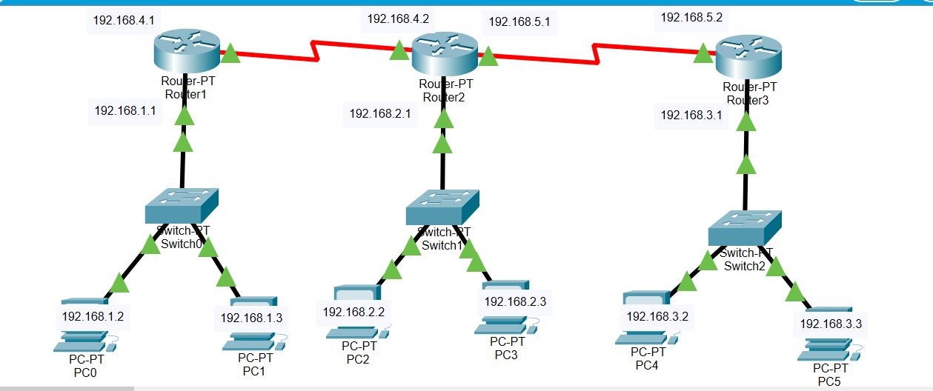

Status:

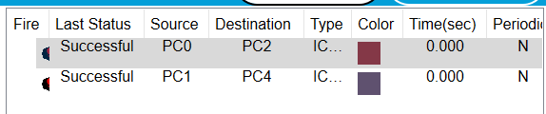

R1: R2: **R3:**

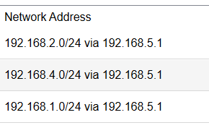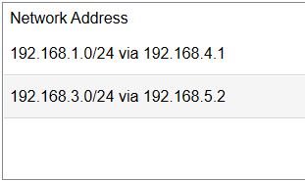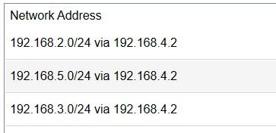

Ping CMD:

